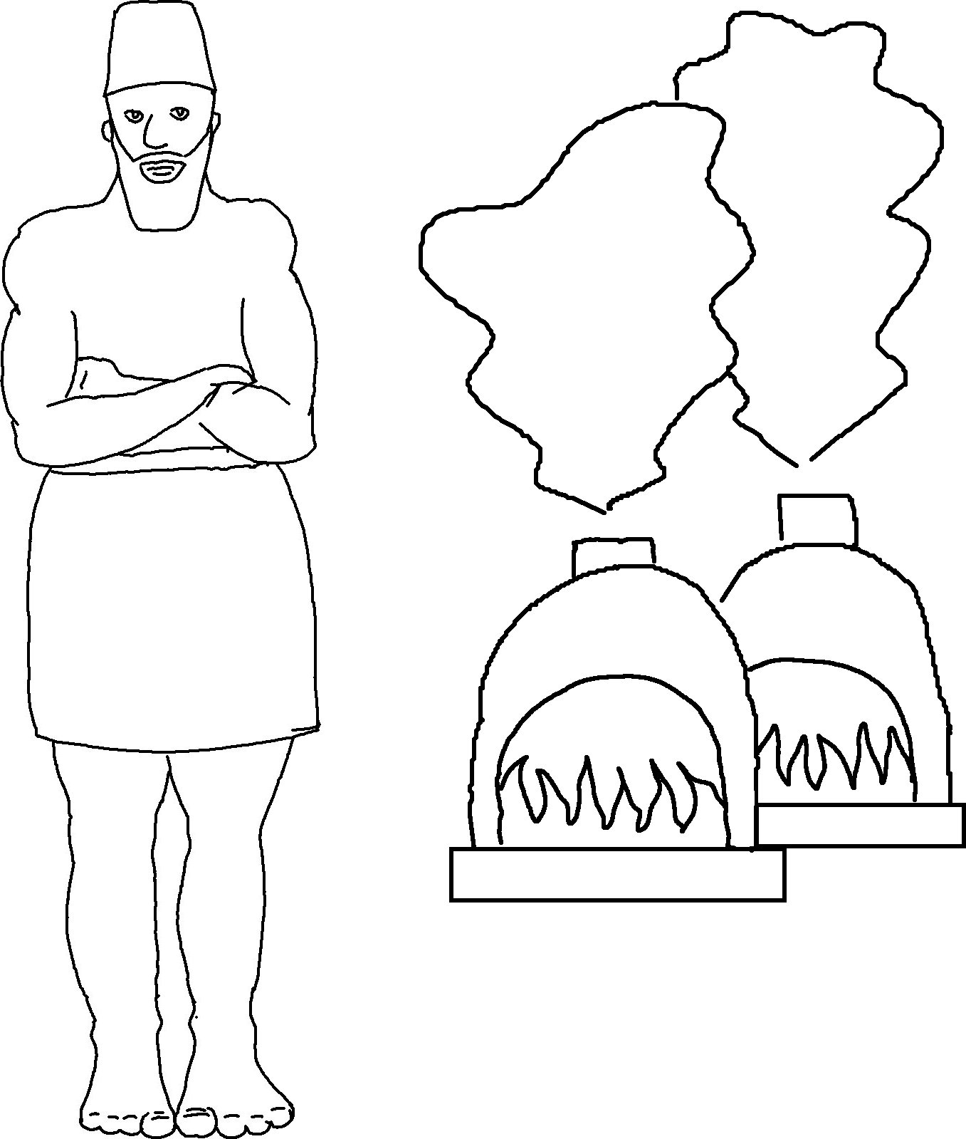

I am the Lord your God.
…so don't be afraid.
I am here to help you.
Isaiah 41:13_{CEV}

